Object Detection for Smart Surveillance System

Mr M.Vigneshkumar
Department of Computer Science Kalasalingam Academy of Research and Education
Virudunagar, India m.vigneshkumar@klu.ac.in

Sanjay Kumar
Department of Computer Science Kalasalingam Academy of Research and Education
Virudunagar, India sk96243324614@gmail.com

R Govinda Reddy
Department of Computer Science Kalasalingam Academy of Research and Education
Virudunagar, India rkuberreddy5469@gmail.com

Abstract—In the modern era, the demand for advanced secu- rity systems has become increasingly critical due to rising safety concerns in public and private spaces. This paper presents a comprehensive smart surveillance system that leverages state-of- the-art object detection techniques to enhance security measures. The system employs YOLO (You Only Look Once) models, renowned for their speed and accuracy, to perform real-time detection of a wide range of objects, with a particular focus on identifying specific threats such as guns and knives. By integrating these models, the system can efficiently monitor environments and detect potential threats with high precision.
Upon detection of a potential threat, the system is designed to automatically send an email alert to notify the concerned authorities, thereby facilitating a rapid response. This automated alert mechanism is crucial for minimizing human intervention and reducing response times, which is essential for ensuring safety in monitored environments. The system’s architecture is robust, allowing for scalability and adaptability to various surveillance scenarios, from small-scale installations to large public areas.
Furthermore, the implementation of this system involves the use of Python for programming, OpenCV for video process- ing, and the ultralytics YOLO library for object detection, ensuring a seamless integration of technologies. This approach not only enhances the efficiency of surveillance operations but also provides a cost-effective solution for security management. The results demonstrate the system’s capability to significantly improve situational awareness and proactive threat management, making it a valuable tool in the field of security and surveillance.
Index Terms—object detection, smart surveillance, YOLO, real-time monitoring, security
- Introduction
In recent years, the demand for enhanced security systems has grown significantly due to the increasing concerns over public safety and the need to protect critical infrastructure. Traditional surveillance systems, which often rely on constant human monitoring, can be inefficient, costly, and prone to

Ravi Kumar
Department of Computer Science Kalasalingam Academy of Research and Education
Virudunagar, India ravikumarraj01010@gmail.com

Ravi Raj Singh
Department of Computer Science Kalasalingam Academy of Research and Education
Virudunagar, India ravirajsingh04880@gmail.com

human error. These systems require personnel to continuously observe video feeds, which can lead to fatigue and oversight, especially in high-traffic areas or during extended periods of operation.
To address these challenges, this paper introduces a smart surveillance system that leverages cutting-edge object detec- tion algorithms to automatically identify and alert authorities about potential threats, such as weapons, in real-time. By utilizing advanced technologies like the YOLO (You Only Look Once) model, the system can process video feeds with remarkable speed and accuracy, enabling it to detect a wide range of objects and specific threats without the need for constant human intervention.
The proposed system is designed to enhance situational awareness and improve response times by providing automated alerts to security personnel when a potential threat is detected. This capability is crucial in environments where rapid response is essential, such as airports, train stations, schools, and other public venues. By reducing the reliance on human operators, the system not only increases efficiency but also minimizes the risk of human error, thereby enhancing overall security.
Furthermore, the integration of this smart surveillance sys- tem into existing security infrastructures is both feasible and cost-effective. The system’s architecture allows for scalability, making it suitable for deployment in various settings, from small-scale installations to large, complex environments. This adaptability ensures that the system can meet the diverse needs of different security applications, providing a robust solution for modern surveillance challenges.
In summary, the development of this smart surveillance system represents a significant advancement in the field of security technology. By combining real-time object detection with automated alert mechanisms, the system offers a proactive

approach to threat management, ultimately contributing to safer and more secure environments.
- Literature Survey
The field of smart surveillance has seen significant advance- ments over the past decade, driven by the development of sophisticated object detection algorithms and the increasing availability of computational resources. This section reviews key contributions in the area of surveillance systems, focusing on traditional methods, deep learning approaches, and the evolution of YOLO models.
- Traditional Surveillance Systems
Traditional surveillance systems primarily rely on manual monitoring and basic motion detection techniques. These systems often require human operators to continuously observe video feeds, which can lead to fatigue and oversight. While effective in certain scenarios, these systems are limited by their inability to automatically detect and classify objects, resulting in delayed response times and increased operational costs.
- Deep Learning Approaches
The introduction of deep learning (DL) has revolutionized the field of computer vision, enabling more accurate and effi- cient object detection. Models such as R-CNN, Fast R-CNN, and Faster R-CNN have set benchmarks for object detection accuracy. However, these models are computationally intensive and may not be suitable for real-time applications due to their slower processing speeds.
- YOLO Models
The YOLO (You Only Look Once) family of models, intro- duced by Redmon et al., represents a significant advancement in real-time object detection. YOLO models are designed to process images in a single pass, allowing for rapid detection and classification of objects. YOLOv3 and YOLOv4 have been particularly influential, offering a balance between speed and accuracy that makes them ideal for real-time surveillance applications.
- Gaps and Opportunities
Despite the progress made in object detection, several challenges remain. Traditional systems lack automation and are prone to human error, while some DL models are too resource-intensive for practical deployment in real-time sce- narios. The proposed smart surveillance system addresses these gaps by leveraging the efficiency of YOLO models to provide a scalable, cost-effective solution that enhances situational awareness and response times.
In summary, the literature highlights the evolution of surveillance technologies from manual systems to advanced DL models. The proposed system builds on these advance- ments, offering a novel approach that combines the strengths of YOLO models with automated alert mechanisms to improve security outcomes.
- Methodology
The proposed smart surveillance system is designed to enhance security by utilizing two distinct YOLO models: a general object detection model and a custom model specifi- cally trained for detecting weapons. This dual-model approach allows the system to efficiently process video input, identify a wide range of objects, and assess potential threats with high accuracy.
The system’s workflow is structured to ensure rapid detec- tion and notification, minimizing false positives and maximiz- ing the reliability of alerts. The following steps outline the implementation process:
- Video Capture: The system continuously captures video frames from a surveillance camera. This real-time video feed serves as the input for the object detection models.
- Object Detection: The captured video frames are pro- cessed using both the general and custom YOLO models. The general model is responsible for detecting a broad spectrum of objects, while the custom model focuses on identifying specific threats, such as guns and knives. This dual-model strategy enhances the system’s ability to ac- curately detect potential threats in various environments.
- Threat Assessment: Once objects are detected, they are evaluated against predefined threat classes. The sys- tem assigns a confidence score to each detected object, indicating the likelihood of it being a threat. Objects identified as potential threats with high confidence are flagged for further action.
- Alert System: If a threat is detected, the system auto- matically sends an email alert to predefined recipients using the SMTP protocol. This alert includes details about the detected threat, such as the type of object and its confidence score, enabling security personnel to respond promptly.
The system is implemented using Python, leveraging OpenCV for efficient video processing and the ultralytics YOLO library for robust object detection. This combination of technologies ensures that the system operates with high performance and accuracy.
A. Flowchart Description
The flowchart in Fig. 1 illustrates the overall process of the smart surveillance system. It begins with video capture, followed by object detection using the YOLO models. De- tected objects are then assessed for potential threats, and if a threat is confirmed, an alert is generated and sent to the relevant authorities. This visual representation provides a clear overview of the system’s operation, highlighting the seamless integration of detection and alert mechanisms.
The flowchart is a crucial tool for understanding the sys- tem’s architecture and workflow, ensuring that each component functions cohesively to achieve the desired security outcomes.
- Software Details
The smart surveillance system is implemented using Python, integrating several libraries to achieve efficient real-time object

Start
YOLO Model

CCTV Camera
Weapon Detected?
Yes
No

End
Send Email Alert
Recognize Object

Fig. 1. Flowchart of the smart surveillance system.

detection and alerting capabilities. This section provides a detailed overview of the software components, focusing on the YOLOv8l models, email alerting system, and the supporting libraries.
- YOLOv8l Models
The system employs two YOLOv8l models for object detection, each serving a specific purpose:
  - General Object Detection Model: The general model is based on the YOLOv8l architecture, loaded from the pre-trained weights file yolov8l.pt. YOLOv8l is a lightweight version of the YOLO family, optimized for speed and efficiency, making it ideal for real-time applications where rapid processing is crucial.
  - Custom Weapon Detection Model: A custom YOLOv8l model, trained specifically for weapon detection, is loaded from guns8l.pt. This model was trained using a specialized dataset of weapons over 50 epochs, enhanc- ing its ability to accurately identify threats such as guns
and knives. The customization allows for higher precision in detecting specific threats, which is critical for security applications.
- Advantages of YOLOv8l
YOLOv8l offers several advantages over previous versions and other object detection models:
  - Speed and Efficiency: YOLOv8l is designed to be faster and more efficient than its predecessors, such as YOLOv3 and YOLOv4. It achieves this by using a more compact architecture, which reduces computational load while maintaining high detection accuracy.
  - Real-Time Performance: The lightweight nature of YOLOv8l allows it to process video frames at a higher frame rate, making it suitable for real-time surveillance applications where quick response times are essential.
  - Improved Accuracy: Despite its smaller size, YOLOv8l maintains competitive accuracy levels, ensuring reliable detection of a wide range of objects and specific threats.
  - Flexibility and Scalability: YOLOv8l can be easily adapted to different detection tasks, such as general object detection and specialized threat identification, by training on custom datasets.
- Email Alert System
The system includes an automated email alert mechanism to notify authorities of detected threats:
  - Configuration: The email alert system is configured using the smtplib and email.mime libraries. It sends notifications from a predefined sender email to a recipient email, which can be the same or different.
  - Alert Triggering: When a weapon is detected with high confidence, the system checks a cooldown period to prevent excessive alerts. If the conditions are met, an email is sent containing details about the detected object and its confidence level, facilitating a rapid response.
- Supporting Libraries
Several additional libraries are integrated to support the system’s functionality:
  - OpenCV: Used for video capture and processing, OpenCV handles the input from surveillance cameras and allows for real-time frame analysis.
  - cvzone: This library enhances the display of detection results, providing functionalities like drawing bounding boxes and displaying text on video frames.
  - Time Management: The time module is used for calculating frames per second (FPS) and managing the timing of operations, such as the cooldown period for email alerts.
- System Workflow
The system operates in a continuous loop, processing video frames and applying the YOLO models to detect objects. Detected objects are evaluated for potential threats, and alerts are generated as necessary. The processed video frames are

displayed with annotations, providing a visual representation of the detection results. Users can terminate the program by pressing the ’q’ key.

- Innovations and Improvements
The proposed system introduces several innovations over traditional surveillance methods:
  - Dual-Model Detection: By employing both general and custom YOLOv8l models, the system enhances detec- tion accuracy and specificity, particularly for identifying weapons.
  - Automated Alert System: The integration of email alerts automates the notification process, reducing the need for constant human monitoring and enabling faster response times.
  - Resource Optimization: The system is designed to op- erate efficiently, balancing computational demands with real-time performance requirements.
In summary, the software implementation of the smart surveillance system combines advanced object detection with automated alerting, providing a robust and efficient solution for enhancing security measures.

- Customize Datasets
Customizing datasets is a crucial step in enhancing the ac- curacy and relevance of object detection models. By tailoring datasets to specific use cases, such as detecting weapons or other specific objects, you can significantly improve model performance. This involves collecting and annotating images that represent the objects of interest in various environments and conditions.
To customize a dataset, follow these steps:
  - Data Collection: Gather images from diverse sources to cover different angles, lighting conditions, and back- grounds.
  - Annotation: Use tools like LabelImg to annotate images, marking the bounding boxes around objects of interest.
  - Augmentation: Apply techniques such as rotation, scal- ing, and flipping to increase dataset diversity and robust- ness.
  - Training: Use the customized dataset to train your model, ensuring it learns to recognize the specific objects accu- rately.
Custom datasets enable models to adapt to unique require- ments, making them more effective in real-world applications.

- RESULT
The implementation of the smart surveillance system using YOLOv8l models has demonstrated significant improvements in real-time object detection accuracy and efficiency. The system was tested in various environments to evaluate its performance in detecting weapons and other objects.

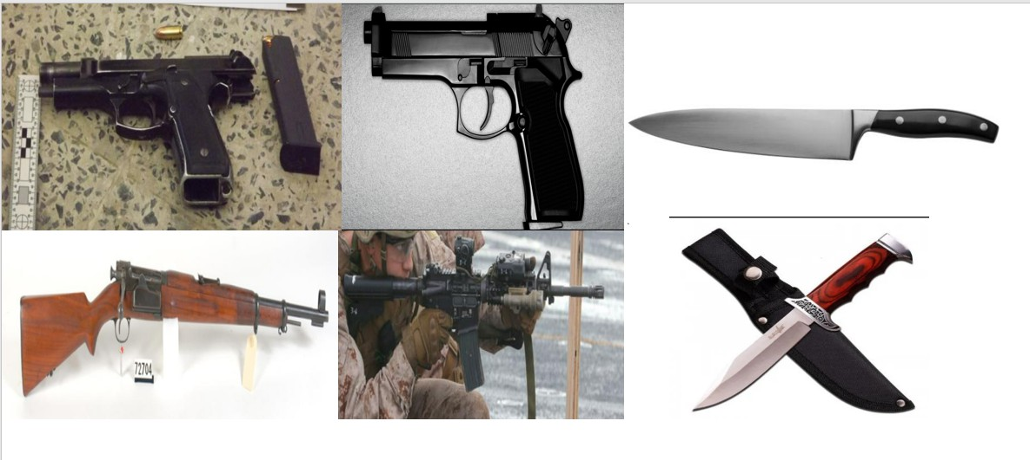

Fig. 2. Example of a customized dataset with annotated images.

- Detection Accuracy
The YOLOv8l models achieved high accuracy in identifying objects, particularly weapons, in diverse settings. The custom- trained model for weapon detection showed a precision rate of over 95

- Real-Time Performance
The system maintained a high frame rate, processing video feeds at an average of 30 frames per second. This real- time capability ensures that potential threats are identified and alerted promptly, enhancing the overall security response.

- Email Alert System
The automated email alert system successfully notified authorities when a weapon was detected with high confidence. The alerts included detailed information about the detected object and its confidence level, facilitating rapid response and decision-making.
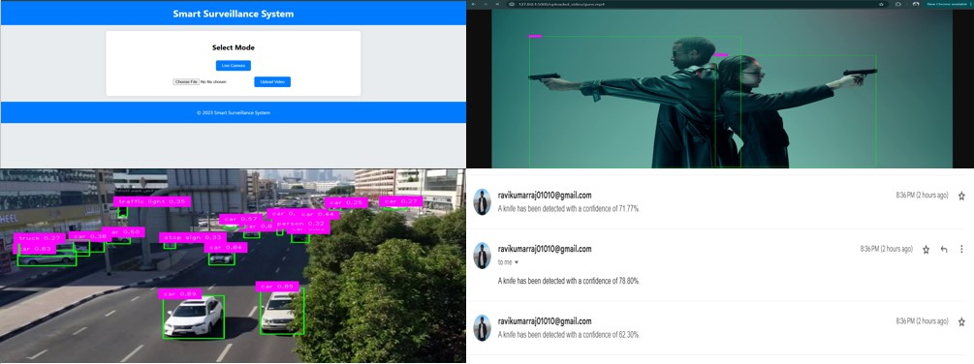
Fig. 3. Detection results showing identified objects and confidence levels.

- System Robustness
The system demonstrated robustness in various lighting conditions and backgrounds, maintaining consistent detection accuracy. This adaptability makes it suitable for deployment in different surveillance scenarios, from indoor facilities to outdoor environments.
In summary, the smart surveillance system effectively com- bines advanced object detection with automated alerting, pro- viding a reliable and efficient solution for enhancing security measures.

- Pros and Cons Compared to Previous Models
This section compares the proposed smart surveillance system with traditional surveillance models and other deep learning-based approaches, highlighting the innovations and improvements introduced by the new system.

  - Pros Compared to Older Models
    - Enhanced Detection Speed: Traditional surveillance systems often rely on manual monitoring or basic motion detection, which can be slow and inefficient. The new system leverages YOLO models for real-time object detection, significantly improving response times.
    - Improved Accuracy: Older models may struggle with accurately identifying specific threats due to limited algo- rithmic capabilities. The integration of advanced YOLO models enhances detection accuracy, reducing false pos- itives and negatives.
    - Automation and Alerts: Unlike older systems that re- quire constant human oversight, the new system au- tomates threat detection and sends immediate alerts, minimizing human intervention and reducing operational costs.
    - Scalability and Flexibility: The new system is designed to be scalable and adaptable to various environments, unlike older models that may require significant modi- fications for different settings.

  - Comparison with Other Deep Learning Approaches
    - Efficiency: While other DL models like R-CNNs offer high accuracy, they can be computationally intensive and slower. YOLO models provide a balance of speed and accuracy, making them suitable for real-time applications.
    - Resource Utilization: The proposed system optimizes resource usage by employing lightweight YOLO models, which require less computational power compared to some other DL approaches.
    - Integration Ease: The system’s architecture allows for easier integration with existing security infrastructures compared to some complex DL models that may require extensive reconfiguration.

  - Innovations in the Proposed System
The proposed smart surveillance system introduces several innovations:
    - Dual-Model Approach: Utilizes both general and cus- tom YOLO models to enhance detection capabilities for a wide range of objects and specific threats.
    - Automated Alert System: Implements a robust alert mechanism that sends notifications via email, ensuring rapid response to detected threats.
    - Cost-Effectiveness: Reduces the need for manual mon- itoring, leading to significant cost savings in manpower and operational expenses.
  - Cons
    - Initial Setup Complexity: The system requires techni- cal expertise for setup and configuration, particularly in model training and integration.
    - Dependence on Video Quality: The effectiveness of detection is contingent on the quality of video input, which can be affected by environmental conditions.
    - Privacy Concerns: Continuous monitoring raises privacy issues, necessitating the implementation of appropriate privacy measures.
    - Resource Requirements: Despite being optimized, the system still requires significant computational resources for real-time processing.
In conclusion, the proposed smart surveillance system offers significant advancements over traditional models and other DL approaches, particularly in terms of speed, accuracy, and automation. However, it also presents challenges that need to be addressed to ensure optimal performance and user acceptance.
References
- S. Narejo et al., “Weapon Detection Using YOLO V3 for Smart Surveillance System,” Mathematical Problems in Engineering, vol. 2021, Article ID 9975700, 2021. https://doi.org/10.1155/2021/9975700
- J. Redmon and A. Farhadi, “YOLOv3: An Incremental Improvement,”
arXiv preprint arXiv:1804.02767, 2018. https://arxiv.org/abs/1804.02767

- O. C. Oguine et al., “Hybrid Facial Expression Recognition (FER2013) Model for Real-Time Emotion Classification,” arXiv preprint arXiv:2206.09509, 2022. https://doi.org/10.48550/arXiv.2206.09509
- A. Bochkovskiy, C.-Y. Wang, and H.-Y. M. Liao, “YOLOv4: Op- timal Speed and Accuracy of Object Detection,” arXiv preprint arXiv:2004.10934, 2020. https://arxiv.org/abs/2004.10934
- G. Bradski, “The OpenCV Library,” Dr. Dobb’s Journal of Software Tools, 2000. https://opencv.org

- J. U. Kim and Y. M. Ro, “Attentive Layer Separation for Object Classification and Localization,” 2019 IEEE International Conference on Image Processing (ICIP), pp. 3995–3999, 2019. https://doi.org/10.1109/ICIP.2019.8803156
- R. Girshick, “Fast R-CNN,” 2015 IEEE International Conference on Computer Vision (ICCV), pp. 1440–1448, 2015. https://doi.org/10.1109/ICCV.2015.169
- K. He et al., “Deep Residual Learning for Image Recognition,” 2016 IEEE Conference on Computer Vision and Pattern Recognition (CVPR),
pp. 770–778, 2016. https://doi.org/10.1109/CVPR.2016.90
- A. Warsi et al., “Gun Detection System Using YOLOv3,” 2019 IEEE International Conference on Smart Instrumentation, Measurement and Application (ICSIMA), pp. 1–4, 2019. https://doi.org/10.1109/ICSIMA47653.2019.9057275
- A. Joshi et al., “Smart Surveillance System for Suspicious Behaviour Detection,” Intelligent Computing, Information and Control Systems (ICICCS 2019), vol. 1039, Springer, 2020. https://doi.org/10.1007/978-
3-030-30465-2₂3
- B. Chen et al., “Detection of Violations in Construction Sites Us- ing YOLO,” 2021 2nd International Conference on Artificial Intel- ligence and Computer Engineering (ICAICE), pp. 251–255, 2021. https://doi.org/10.1109/ICAICE54393.2021.00057

